Ajinomoto Philippines – Material Planning, PR-PO, ASN & GR Requirements
Workshop Session 2 · Oct 27, 2026 · @Srini

1. Workshop context and scope
Session 2 mapped how materials go from monthly demand planning to purchase, delivery, receipt and quality release. Most hand-offs today run on Excel and email, and SAP S/4HANA is used mainly for financial postings.
Item | Detail
Client | Ajinomoto Philippines Corporation (APC), Project Beacon
Session | Workshop Session 2 – Jedox, SAP S/4HANA and Infor for material planning, PR, PO, GR and ASN, 27 Oct 2026
Durvah team | Kishore, Sunit Nighut
Ajinomoto – supply planning | Maya Dausin (senior/section manager, supply planning), Rachelle Sucayan, material planning specialists (RM and PM)
Ajinomoto – procurement | Chris Ballesteros (Beacon lead), Joshua Omus, Reyjoseph Sumodlayon and team
Ajinomoto – IT | Darylann Malabo, Joannacris Escanilla, Johnleonard Salvadico
Other participants | Nhorien Tayco, Majeed Santiago, Maryann Perez, Vironeca Arevalo, Carol Llorente, Janischristine Alday
Systems in the current landscape
System | Role today
Jedox | Monthly MRP and planning engine; holds MRP parameters (safety stock, lead time) and BOMs; vendor master interfaced from SAP; vendor allocation feature exists but is not active
SAP S/4HANA | Inventory and finance; PR and PO; sales orders and shipments. No production planning module and no BOM in SAP. Implemented mainly for financials
Infor WMS | Warehouse receiving, put-away, pass/fail stock restriction, shipments; interfaced to SAP in real time
LIMS (planned) | Future quality inspection system; quality module not yet live
DataSpider | Middleware for SAP integrations
Excel / email | Sales forecast, production plan, vendor allocation sheet, vendor commitment file, NCR and CAR tracking, supplier communication
Related: the R&D new-material request was revisited at the start of this session; see Day 1 (supplier onboarding). The QC receiving and LIMS session is scheduled for 28 Oct.

2. Current process (as-is)
MRP runs monthly in Jedox, but vendor allocation, delivery commitments and quality feedback all happen in Excel and email. Only the PO, the receipt and the inventory postings reach SAP.
A. New material request (from R&D)
- An R&D specialist emails procurement, often as a one-line sample request with no specification attached.
- Procurement checks whether an existing vendor carries the material, otherwise searches the market, and requests samples, specifications and indicative cost.
- Cost and initial technical fit are checked against R&D's indicative cost, with marketing input.
- Samples, technical review, trial, CPN and stability tests run outside any system, followed by the supplier audit and QA document review.
- A new vendor is created in SAP. An existing vendor is tagged to the new material code.
Packing material vendors are usually sourced by procurement, not R&D. For an existing item from a new vendor, QC still applies but is limited to a machinability test, so lead time is shorter.
B. Planning to PO
- A monthly Demand Management Meeting agrees the rolling forecast, promotions and the annual production requirement.
- The sales forecast and production plan are uploaded to Jedox from Excel. MRP parameters (safety stock, lead time) are also loaded from Excel.
- Jedox MRP gives the required materials, quantities and dates. It runs on a monthly cycle, on day 11.
- Procurement allocates each requirement to vendors in an Excel allocation sheet using a split percentage (for example 60/40), MOQ, quality performance and volume. Some SKUs must come from one specific supplier.
- Procurement manually creates the PR and converts it to a PO in SAP, splitting lines by vendor by hand. The PO price is typed in from the latest quotation.
- The PO is emailed to the supplier, who acknowledges it and sends a delivery schedule.
C. Delivery commitment and tracking
- Supply planning maintains a vendor commitment Excel file listing PO, vendor, material and committed schedule. It is linked to the planning team's MRP file and shared by email.
- Key suppliers send a full delivery schedule and later update it. Changes arrive by email or Viber and go into the Excel file only. PO delivery dates in SAP are not updated.
- The updated commitment feeds back into the next MRP cycle to find stock-out risks and order ahead.
D. Receiving, quality and non-conformance
- Goods are received in Infor WMS. Its “ASN” is an internal import document, not a supplier advance shipping notice. Receipts, partial receipts, rejections and returns post to SAP in real time.
- WMS restricts stock until QC passes. The factory QC releases a certificate and WMS is set to pass or fail manually. Test parameters and results are not held in any system.
- On a quality failure, the factory issues a Non-Conformance Report (NCR). Procurement emails it to the supplier.
- The supplier returns a Corrective Action Report (CAR). Local suppliers get on-site verification, and APC monitors the next three deliveries before closing the NCR. All of this is tracked in Excel.
E. Production and finished goods
- The planning system translates the production plan into material needs using the BOM in Jedox. There is no BOM in SAP.
- Production orders RM and PM through WMS, and WMS moves stock to the production location by transfer posting.
- Consumption is manually deducted in SAP and finished goods are received without reference, followed by a stock transfer to the distribution centre (see section 4).

3. As-is process flow
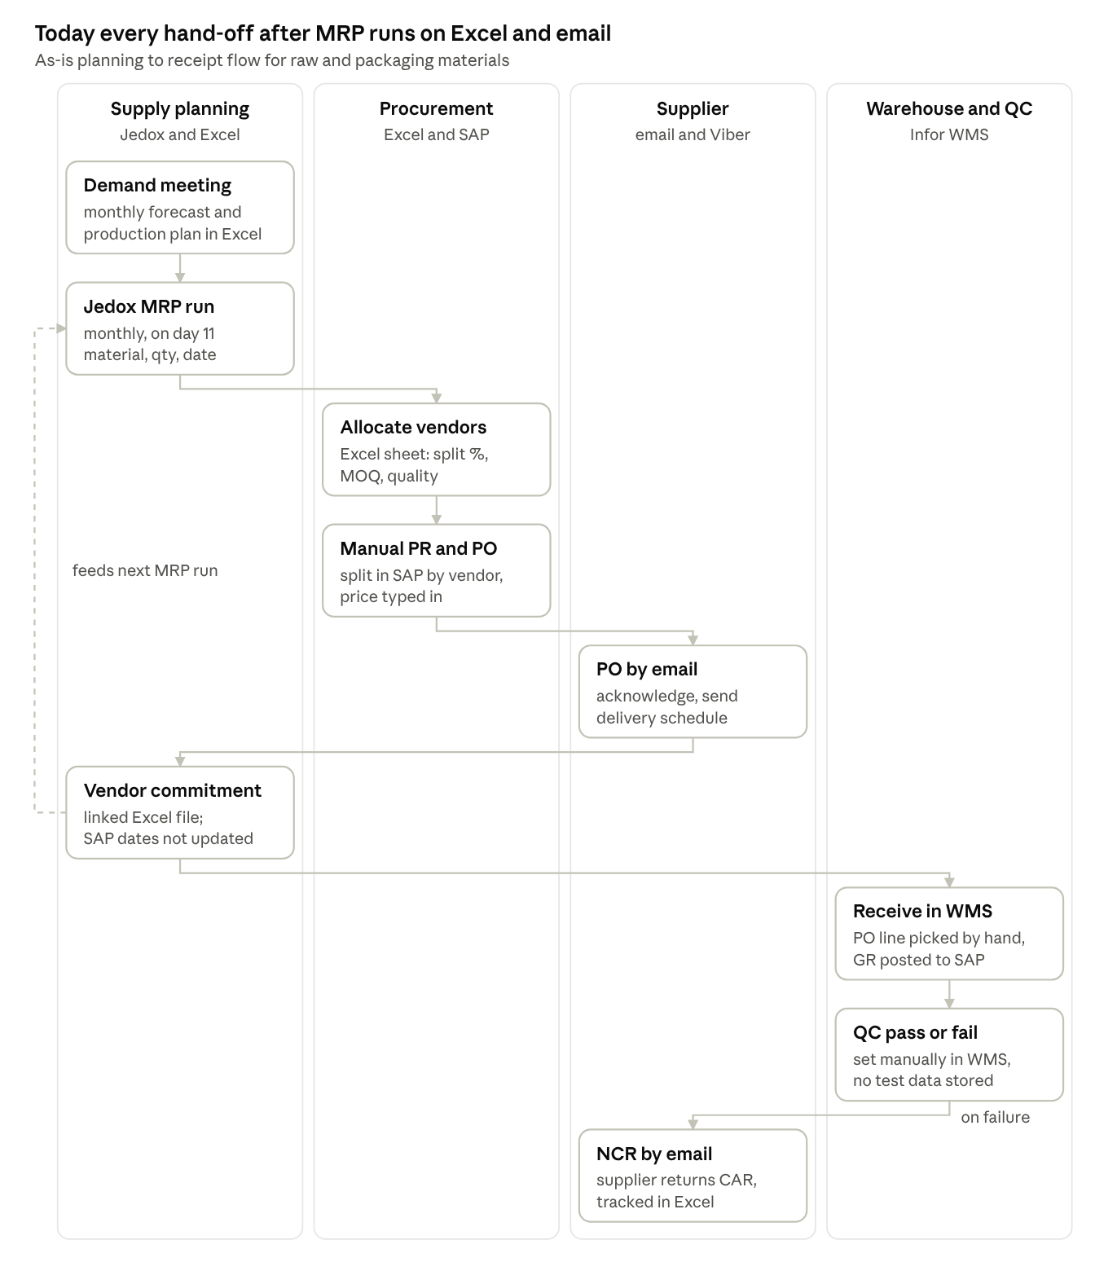
As-is planning to receipt · 4 lanes, 9 steps
The vendor commitment file is the hinge of the current process: it carries supplier dates back into planning, but SAP never sees them.

4. Current SAP inventory transactions
Without PP and BOMs in SAP, production is recorded through custom goods movements without reference. SAP inventory is right only if each manual posting is made.
Step | Where it starts | SAP posting
RM/PM goods receipt against PO | Infor WMS receipt | GR against PO, interfaced in real time
RM/PM issued to production location | WMS order / shipment order | Transfer posting (same plant, storage location to storage location)
RM/PM consumption | Manual, based on production output | MIGO goods issue – Other, movement type Z05 (custom), no production order
FG produced | Manual, based on production output | MIGO goods receipt – Other, movement type Z01 (custom), without reference
FG to distribution centre | WMS inbound acceptance at FG warehouse | Stock transfer (production plant to distribution centre plant)
Returns and rejections | WMS | Posted to SAP via interface

5. Pain areas
The main pain is that supplier commitments, allocations and quality outcomes live in linked Excel files that only the planners can read and keep in step.
# | Pain area | Impact
P1 | R&D new-material requests arrive as one-line emails with no specification | Procurement chases detail; no tracked request
P2 | Sales forecast, production plan and MRP parameters uploaded to Jedox from Excel | Manual effort and risk of upload errors each cycle
P3 | Vendor allocation (split %, MOQ, quality, single-source SKUs) done manually in Excel | Inconsistent decisions; effort; no audit trail
P4 | PR creation and PR-to-PO conversion with vendor splits done by hand in SAP | Errors in line selection; effort
P5 | PO prices typed from latest quotation; no outline agreements | Price errors; repeated RFQs (also raised on Day 1)
P6 | PO acknowledgement and delivery schedules exchanged by email and Viber | No single source of truth; slow updates
P7 | Vendor commitment file is a heavily linked Excel workbook | Planners struggle to find and maintain files; links break
P8 | SAP PO delivery dates not updated when suppliers change schedules | SAP open-PO view does not match reality
P9 | No supplier ASN; WMS receivers pick PO lines by hand | Wrong line received when one PO has several schedule lines for the same material; other lines show as delayed or not received
P10 | Over-delivery within tolerance and short deliveries are not measured | Suppliers exploit tolerance; no data for performance
P11 | QC pass/fail set manually in WMS; test results not in any system | No traceable quality record per GR line
P12 | NCR and CAR sent by email; three-delivery verification tracked in Excel | Slow closure; no supplier quality history
P13 | No reason codes for late delivery, and some delays are caused by APC (production, warehouse, typhoon, port) | On-time metrics would be wrong without reason capture
P14 | Consumption and FG receipts posted manually with custom movement types; BOM maintained only in Jedox | Inventory accuracy depends on manual postings; SAP used mainly for financials

6. To-be process
In the target design, supplier collaboration moves from email and Excel into the procurement platform. Planning stays in a planning engine, and SAP stays the system of record for PO, GR, inventory and finance.
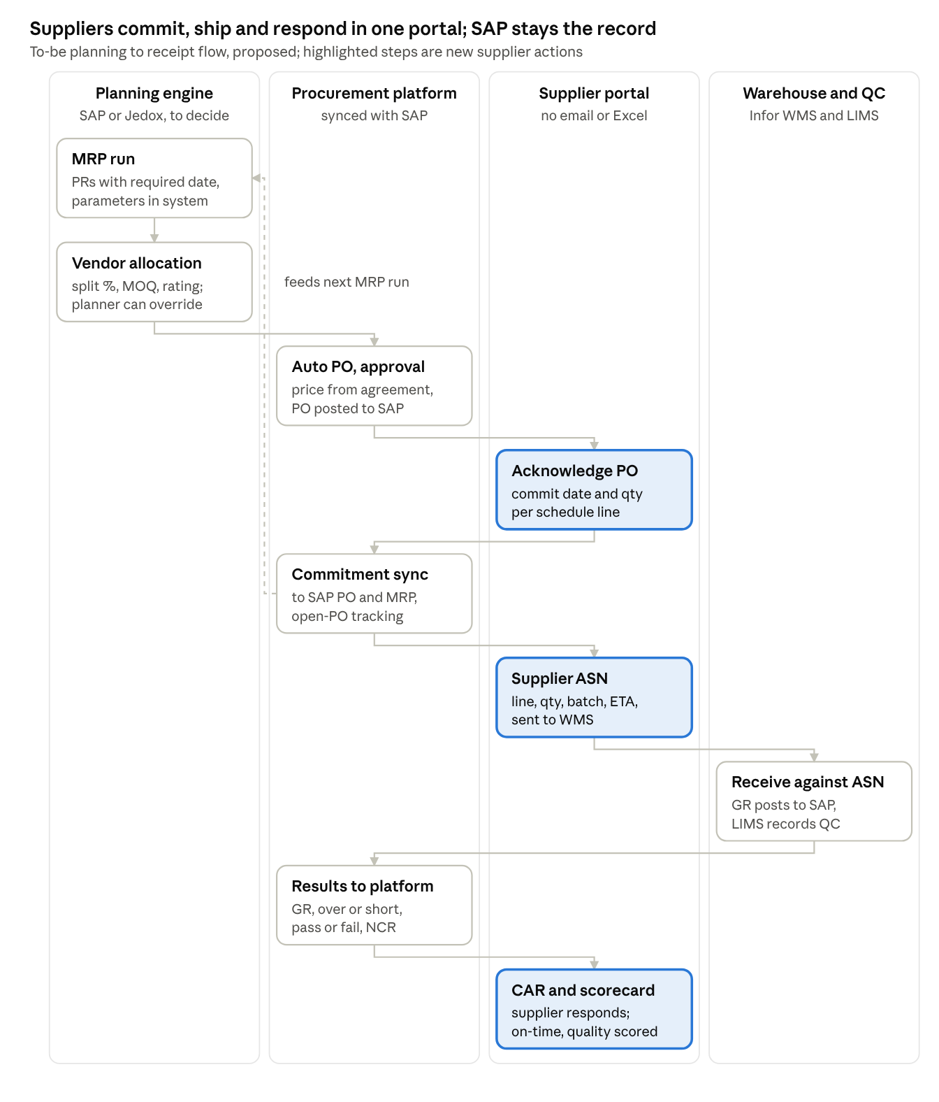
To-be planning to receipt · 4 lanes, 9 steps
What changes:
- The vendor commitment Excel file is retired. Supplier commitments update the SAP PO lines and the next MRP run directly.
- The supplier ASN tells WMS exactly which PO line and schedule line is arriving, so receivers no longer pick lines by hand.
- Receipts, over and short quantities, QC results and NCRs reach the supplier in the portal, and the CAR comes back the same way.
- On-time and quality scores are calculated from transactions (committed date vs actual receipt; rejections and returns), with reason codes excluding APC-caused delays.
- Where vendor allocation runs (SAP, Jedox or the platform) is still open; see section 8.

7. Functional requirements
Twenty requirements came out of Session 2. The must-haves are a supplier portal for PO acknowledgement, schedule commitment and ASN, plus closed-loop quality feedback. Priorities are Durvah's proposal for Ajinomoto to confirm.
ID | Area | Requirement | Priority
PP-01 | Material request | R&D raises new-material requests in the platform with specification, target cost and attachments; routed to procurement to start sourcing | Must
PP-02 | Requisition | Receive approved PRs from SAP (or the MRP engine); optionally create PRs in the platform where permitted | Must
PP-03 | Vendor allocation | Auto-assign vendors per material using allocation %, MOQ, single-source rules, supplier rating and quality blocks; planner can review and override before PO creation | Must – location to be decided (section 8)
PP-04 | Auto PO | Create POs automatically from allocated PRs, with price from the agreement or outline agreement; approval by the approving head | Must
PP-05 | PO publication | Publish approved POs to suppliers in the portal; supplier acknowledges | Must
PP-06 | Schedule commitment | Supplier confirms or proposes delivery date and quantity per PO line or schedule line against the MRP required date | Must
PP-07 | Commitment feedback | Committed dates flow back to SAP PO lines and to the MRP engine for the next run, replacing the vendor commitment Excel file | Must
PP-08 | Schedule changes | Suppliers update schedules in the portal with reason; procurement and planning notified; change history kept | Must
PP-09 | Open PO tracking | Dashboard of open PO lines, committed vs required dates and at-risk deliveries for procurement and planning | Must
PP-10 | Supplier ASN | Supplier creates an electronic ASN at dispatch with PO line, schedule line, quantity, batch and ETA; sent to Infor WMS for receiving | Must
PP-11 | Receipt visibility | GR, partial receipts, over/short receipts, rejections and returns from WMS/SAP visible against each PO line, internally and to the supplier | Must
PP-12 | QC result | Pass/fail per GR line from LIMS (or WMS until LIMS is live) shown to the supplier as accepted or rejected | Must
PP-13 | NCR | Factory issues the NCR (report no., NC type, defect class, description, supplier, SKU) and it is sent to the supplier in the portal | Must
PP-14 | CAR | Supplier submits the Corrective Action Report in the portal; APC records first, second and third delivery verifications and closes the NCR | Must
PP-15 | Delivery performance | Measure on-time delivery as actual receipt date vs committed date, and quantity accuracy as over or short vs schedule | Must
PP-16 | Delay reasons | Reason codes for late or changed deliveries (supplier, APC production or warehouse, force majeure such as typhoon or port), captured by procurement or planning and excluded from scoring where APC-caused | Must
PP-17 | Quality performance | Count of rejections, returns and NCRs per supplier from transaction data, feeding the supplier scorecard | Must
PP-18 | Allocation feedback | Supplier rating or quality status can reduce or block allocation of a supplier for a material | Should
PP-19 | Price agreements | Contract or outline agreement prices from sourcing are sent to SAP so PO prices default automatically (links to Day 1 SO-20) | Must
PP-20 | Corrective actions | Procurement or planning can raise corrective action requests to suppliers for delivery issues, not only quality | Should

8. Key design decision: where MRP and vendor allocation run
Durvah's working recommendation is to keep MRP and vendor allocation in a planning system (SAP or Jedox), not in the procurement platform. The platform should handle supplier collaboration from PO onwards. Durvah will issue the final recommendation after reviewing the options below.
Option | What it means | For | Against
A. Activate MRP and source list / quota arrangement in SAP S/4HANA | MRP, PR and vendor assignment run in SAP; PRs and POs go to the platform for supplier collaboration | Standard ERP practice (MRP runs where inventory lives); fewer integrations; APC already reviewing SAP for FY2027 | Needs PP, BOM and planning setup in SAP; change effort for planners
B. Use Jedox vendor allocation | Activate Jedox's existing allocation feature; Jedox sends allocated PRs to SAP | Planners already work in Jedox; vendor master already interfaced | Allocation feature unused so far; Jedox runs monthly; adds Jedox–SAP–platform integrations
C. Allocation in the procurement platform | Platform receives PRs and assigns vendors | Single user interface for procurement | Sourcing platforms have only basic MRP logic; customisation and integration upkeep; not standard
Principles agreed in the room:
- Prefer standard features to customisation, and fewer systems and integrations to maintain.
- SAP stays the system of record for inventory, PO, GR and finance.
- Whatever engine allocates vendors must let planners review and override before POs are created, because of MOQ, single-source SKUs and volume edge cases.

9. Open questions
# | Question | For
Q1 | Will MRP and vendor allocation run in SAP, in Jedox, or elsewhere? Is the FY2027 SAP review in scope for PP and MRP? | APC management, IT
Q2 | How will LIMS record QC results: per PO, GR line and batch? Will it hold the NCR? | QC team – 28 Oct session
Q3 | Can Infor WMS accept a supplier ASN by interface, and which fields does it need? | IT, Infor vendor
Q4 | Which schedule is the baseline for on-time delivery: the original PO date, the first commitment or the latest agreed date? | Procurement, planning
Q5 | Who records delay reasons, and where? WMS has free-text fields but the factory may not know the reason. | Procurement, planning, warehouse
Q6 | What over-delivery tolerance is set per material, and should over-delivery count against suppliers? | Procurement
Q7 | Will Jedox MRP parameters move into SAP material masters if MRP is activated in SAP? | Planning, IT
Q8 | Is DataSpider the middleware for new platform integrations, and who supports it? | IT
Q9 | Does packing material sourcing (procurement-led) need a separate request flow and document set from raw material (R&D-led)? | Procurement, R&D

10. Action items
Ten actions came out of Session 2. The MRP location recommendation from Durvah unblocks the to-be design. Owners are proposed from the discussion; please confirm.
# | Action | Owner | Due | Status
A1 | Recommend where MRP and vendor allocation should run (SAP, Jedox or platform), with the integration landscape | Durvah (Kishore, Sunit) | With requirements pack | Open
A2 | Share the vendor commitment Excel file and the vendor allocation sheet (sample) | Supply planning (Maya Dausin's team) | This week | Open
A3 | Share the NCR, CAR and three-delivery verification templates and the NCR tracking file | QC / procurement | Before 28 Oct session | Open
A4 | Provide an overview of current SAP integrations and middleware (DataSpider), including the WMS–SAP interface | IT (Darylann, Joannacris) | This week | Open
A5 | Confirm Jedox capabilities: vendor allocation module, PR output and interfaces to SAP | IT / supply planning | Before recommendation | Open
A6 | Confirm Infor WMS ASN capability and the fields needed for a supplier ASN interface | IT / warehouse | Before recommendation | Open
A7 | Cover the QC receiving process and LIMS design (results per GR line, NCR) | QC team, Durvah | 28 Oct session | Open
A8 | Agree the delivery performance baseline (committed date) and the list of delay reason codes | Procurement, planning | Before performance session | Open
A9 | Share the FY2027 SAP roadmap (PP / MRP activation plans) | IT, Chris Ballesteros | Next week | Open
A10 | Confirm whether outline agreements can be enabled for RM/PM pricing (carried from Day 1) | IT (SAP team) | Next few days | Open

